FOR IMMEDIATE RELEASE

Local Author Publishes third novel … The Dog Walkers
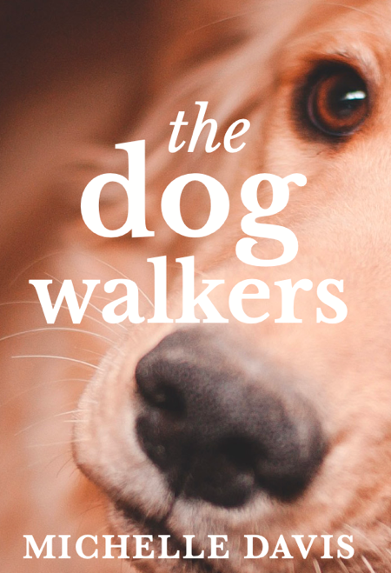

Contact: Michelle Davis
Phone: 610-207-3521
Email – michellemdavis1@me.com
Website: www.michellemdavis.net

“I cannot image a life without dogs. There’s something about their eyes that captivate me. Perhaps it’s how they look at us with unconditional love.” — Michelle Davis

The Dog Walkers, Michelle Davis’s third book, will be released on February 14, 2022. This novel, along with Learning to Bend and The Invitation, are available for purchase at Roundabout Books as well as Amazon, Barnes and Noble, and other online book retailers. A fictional novel, The Dog Walkers tells the tale of Ali Doyle, a software engineer from Philadelphia who self-isolates in her apartment after an emotional breakup because she is afraid of an inevitable encounter with her “ex” at work. Throughout the book, readers experience Ali’s mental fall then slow progression …from anger and denial … through anxiety and depression … and finally to hope and inspiration. Her recovery, though somewhat unconventional, is fueled by an unknown voice and a missing dog walker. Together they provide her with the courage to regain her freedom and discover her true self.

Novel’s Summary

Ali Doyle, a thirty-two-year-old engineer, discovers her boyfriend—who is the legal counsel at the suburban Philadelphia software company where she works—has no intention of marrying her. After an uncharacteristically emotional confrontation, Ali ends this two-year relationship. However, the fear of seeing her ex at work and losing all control causes her to feign an illness, self-isolating in her apartment. At first, she’s fine with the solitude, but when Ali tries to leave, she’s incapable of venturing outside.
While feeling lost and hopeless in this self-quarantined state, Ali discovers solace to her loneliness by watching dog walkers from her front window. In an effort to find human connection, she creates imaginative back stories for these strangers and their pets. Ultimately, it’s her concern for an elderly gentleman and his Golden Retriever, as well as advice from an unexpected voice inside of her head, that give her the strength to leave her apartment building and begin her journey to wellness.
As Ali reemerges from her isolated state, she meets several of the dog walkers, learning their real names and true identities. Through this process, she forms friendships, finds guidance, and eventually falls in love. But most importantly, Ali recovers the missing pieces of herself that she had given away as she confidently learns to release boundaries, surrender control, and establish trust.

A quote from The Dog Walkers:
“Ten days have passed since I’ve entered “phase two,” a term I attached to this contemplative, inward searching stage of my illness. Phase one was denial, a sense I was fine as long as I kept my distance from everyone. But Miles changed all of that when he made me see it wasn’t breaking up with David that caused me to hide—it was something much deeper.”

The Dog Walkers is self-published by Michelle Davis, with exceptional guidance from Lieve Maas.
“Knowing I have many more stories to share, I’ve chosen to self-publish my books, hoping to deliver these novels to readers in a timely and efficient manner.” – Michelle Davis
The Dog Walkers will be available for purchase through Roundabout Books (Bend, Oregon), Amazon, Barnes and Noble, and other online book retailers.
https://www.amazon.com/Michelle-M-Davis/e/B083ZLXBXS?ref_=pe_1724030_132998060
Paperback - $16.99
E-book - $6.99

Please note that 10% of the author’s net proceeds will go to ECPAT, a non-profit organization whose mission is to protect every child’s human right to grow up free from the threat of sexual exploitation and trafficking. For more information, please visit ECPAT’s website - https://www.ecpatusa.org

About the Author
Michelle Davis began The Dog Walkers in November of 2019. Observing unknown dog walkers from her kitchen window, Michelle became curious about who they were and wondered about their lives. This sparked the desire to create the story of Ali Doyle, her self-isolation, and her struggle to face her fears. Little did Michelle know that in three months, we’d all be quarantined, experiencing isolation—and perhaps our own loneliness and worries—firsthand.
The Dog Walkers is Michelle’s third book. Her debut novel, Learning to Bend, shares the story of Jenna Moore’s journey from a safe and predictable life in Boston to Bend, Oregon, where she begins to discover her true self. The Invitation—Michelle’s second novel and the first book in The Awakening Series—delves into the world of spirituality and holistic healing. In addition to writing women’s fiction, Michelle’s blog, elevate, explores finding inspiration, increasing vibration, and embracing limitless possibilities.
To learn more about Michelle or read her blog, visit www.michellemdavis.net

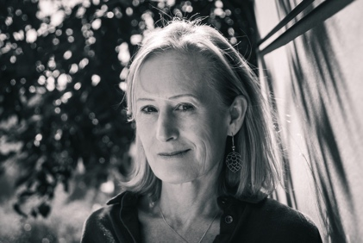
Questions for Michelle:
How do you develop your plot and characters?
The plot usually just comes to me. I know that sounds cliché, but it’s the truth. I’ll often wake up with an idea, or sometimes, while running or even in the shower, I’ll get a thought about the next turn in the book. Regarding characters, that is the fun part. I like to allow my imagination to play and create. Sometimes I’ll look on-line to find pictures of how I think my characters might look like, but it’s usually just to have a tangible representation of what is already in my head. I also like to spend time creating characters’ backstories. Often, during long drives, I’ll run ideas past my husband to see if these individuals are believable. He’s pretty awesome at giving me honest feedback.

What, in your opinion, are the most important elements of good writing?
The first thing that pops into my mind is authenticity. For me, if the writing isn’t authentic to the writer—meaning that it sounds contrived or designed to sell books/please audiences—then something about it makes me wonder if this is the author’s best work.
Another important element of writing is creating believable characters. Can I relate to them, are they multi-dimensional?
Finally, I like to be able to visualize the scene and put myself right there, next to the characters. Does the author provide clear descriptions? Is there movement during the scenes? Does he or she employ language which taps into my senses?

Do you ever suffer from writer’s block? If so, what do you do about it?
Yes, I have hit a wall when writing. Sometimes all that I need is to get away, so I go for a run, take a walk with the dogs, or just go about my day, hoping that at some point inspiration will hit. This usually does the trick. However, separating myself from my work is not always the answer to writer’s block. Four years ago, I had written most of the first draft of this book, but I just couldn’t finish it. I was not able to make the ending come together in a believable fashion. For me, this was writer’s block at it’s worse. So, I shelved the manuscript for three years, realizing I had more to learn before I could finish the book. I continued to pick it up and put it down several times until the missing pieces finally became clear.

What is your favorite quote and why?
“When you know better, you do better.” - Maya Angelou
This quote perfectly depicts what it’s like to be human. We’re constantly learning, evolving, and becoming better. But it requires experiences and lessons from those encounters. Sometimes we regret past actions and cast blame on ourselves. However, if we were trying our best with the tools that we had, then that was all we could do. But now that we know better and are aware of different ways, it is our responsibility to do better. The same applies to others and how they’ve impacted our lives. To me, this quote epitomizes how we can all elevate to our higher selves.

First book you remember making an indelible impression on you.
Tuck Everlasting, by Natalie Babbett, rocked my world at age twenty-four. At the time I was teaching fourth grade at Waldron Mercy Academy in Merion Station, a suburb of Philadelphia. I chose it as a read aloud book for my students—what I’d read at the end of the day before dismissal. Tuck Everlasting helped me understand why we age and how this is the necessary natural process for all of us. Winnie’s struggle of whether to drink the stream water, guaranteeing her everlasting life, prompted a great deal of thought for both my student and for me. It’s still one of my all-time favorite books.

If you could have one paranormal ability, what would it be?

I would like to be Claircognizant. I would love to be able “know.” This ability would provide insight to make the best possible decisions. But more importantly, “knowing” might allow me to deliver intuitive writings—whether books, blogs, or informational pieces—as I would have a truer understanding as to how it all works.

If we were to come to your house for a meal, what would you give us to eat?
I LOVE this question because cooking is so much fun. Here you go:
Appetizers: Cheese and crackers along with freshly cut veggies served with hummus. My husband would make his famous margaritas.
Salad: Caesar salad.
Entrée: A bowl consisting of quinoa, black rice, or roasted chopped sweet potatoes. Then I’d add a variety of sautéed veggies – spinach, zucchini, asparagus, mushrooms, and broccoli. After that I’d then top it with a protein, most likely shrimp or chicken. Finally, I’d add shaved parmesan, sliced almonds, and micro greens.
Desert: Chocolate peanut butter brownies. And, of course, we’d serve yummy wine.

What is the sweetest thing someone has done for you?
When I had breast cancer, I had to undergo a double mastectomy and then four rounds of chemo. My husband was always by my side—Scott was beyond amazing. He would gently wash my hair in the sink when I was unable to wash my own hair in the shower. And when I’d be feeling nauseous from the chemotherapy, he’d make me bacon sandwiches on mushy white bread—the only thing I could stomach. Scott was incredible throughout that entire journey.

What books or authors have most influenced your own writing?
Amy Impellizzeri, author of Lemongrass Hope, The Truth About Thea, The Secret of Worry Dolls, and Why We Lie, encouraged me to attend her writers’ workshop. That was my introduction to writing (not counting my freshman writing class at Lehigh University). She’s been a dear friend ever since and has served as my mentor.
It’s hard to pinpoint a particular book, as I believe my writing is still in its infancy and am unsure as to where it is headed. But I’d have to say that I love the intriguing story line of The Celestine Prophecy. Additionally, the characters are beautifully developed in A Gentleman in Moscow.

What is your favorite television show?
I love watching Friends. I think I’ve seen every episode multiple times. In fact, when I’m home alone at night, I’ll watch rerun after rerun—sometimes till one in the morning. I recently had the “aha” moment that most likely my fondness for Friends connects to my childhood when I loved the Archie comic book series. The characters are almost identical. Plus, Friends has the most amazing cast. Wouldn’t you want them to be your friends with Monica, Phoebe, Rachel, Ross, Joey, and Chandler?

Do you ever wish you were someone else? Who?
When I was four, I wanted to be “Bat Girl” because I loved the television show, Batman, and I wanted to catch “the bad guys.” But I’m guessing that’s not the answer you’re looking for.
During high school I would have loved to have been the popular girl—you know, the tall, thin girl with perfect long blonde hair that everyone loves. Instead, I was the average looking girl who worked hard and got straight A’s. I was nice and had good friends, but I always felt as if something about me was missing. Perhaps what was “missing” was me being authentic to who I truly was … I was kind of nerdy (I think I still am today). No doubt I was uncomfortable in my own skin and thought I had to be someone who I wasn’t. But now that I’ve “grown into myself,” I’ve come to realize how often our perceptions of others can cause us to feel “less than.” It’s too easy to judge another’s strengths and weaknesses then draw imaginary parallels as to how we compare. This is an incredibly unhealthy practice, yet my guess is that we all do it from time to time. So now, I’m incredibly happy to be me, as I try to accept all parts of who I am—the good, the bad, and the in between. That’s one of the blessings of aging … we begin to let go, trust, and allow as we become closer to unconditionally loving ourselves and others.

What is one thing your readers would be most surprised to learn about you?
I think readers would be surprised to learn that I have my Reiki 3 certification. In fact, I receive energy healing every two weeks, helping to keep my chakras balanced. Not only do I believe it’s important to “work out” our physical body, but it is equally, if not more valuable, to “work on” our energetic bodies.

